Risk Profiler

Data By:

Area Scenario Training Download About Contact

Sort By:

Go

Select Scenario by Municipality

Magnitude

# Scenario Catalogue

Filter By:

Scenario Catalogue

Magnitude

Hover over a Scenario to retrieve data:

New? Take The Tour

Risk Layer ?

Adjust Opacity

Scenario Name

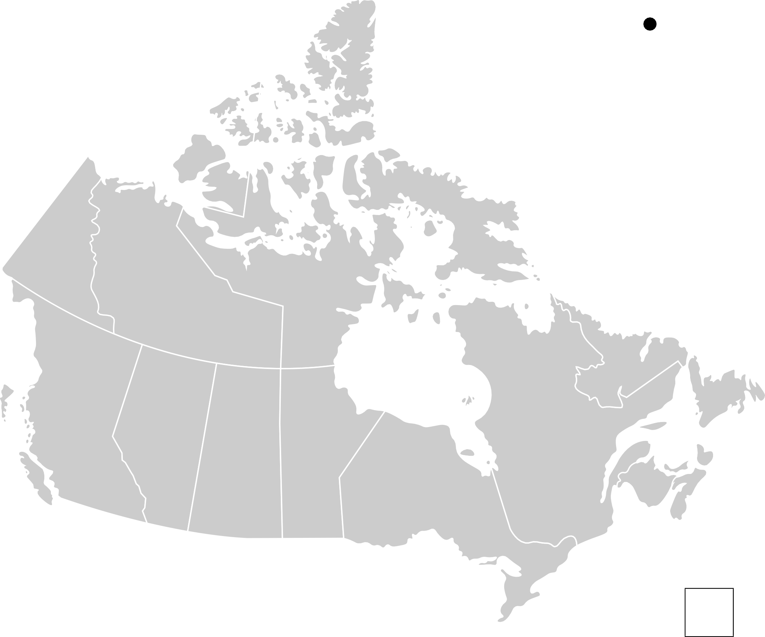

Legend

Magnitude: 4.3

Deaths: 4,323

Dollars: $1,990,999

Downtime: 45 days

Scenario Name

Magnitude: 5.3

Deaths: 5,443

Dollars: $11,790,999

Downtime: 45 days

Scenario Name

Magnitude: 2.6

Deaths: 4,998

Dollars: $19,990,999

Downtime: 21days

Scenario Name

Magnitude: 3.7

Deaths: 2,982

Dollars: $3,000,000

Downtime: 15 days

Scenario Name **+**

Magnitude: 3.7

**-**

Deaths: 2,982

Dollars: $3,000,000

Downtime: 15 days

Footer